Eric Bowers
Penn High School
Mishawaka, Indiana

Hurricanes in Europe?

Grade Level:
This lesson is appropriate for a World Regional Geography class (grade 9). The lesson plan could also be used to teach any class dealing with current/recent events.

Classroom Sessions / Estimated Time:
This lesson plan is designed for a block schedule time period (88 min.). The activities can be done as an introduction or a review. Activity number one might best be used as an introduction and activity number two as a review.

Introduction - Powerpoint – Hurricanes in Europe
Before introducing the Powerpoint, have a class discussion focusing on what to do if a hurricane/severe weather would hit a major European city. Questions may include, "What lessons did we learn from Hurricane Katrina?, What European cities are in danger of a hurricane?, and What steps might a coastal city take to prepare for a hurricane?" This discussion will have the students think about many of the topics covered in the Powerpoint.
The Powerpoint is broken up into 3 different segments. The segments include hurricanes in the US, hurricane preparation in Europe, and future problems. When teaching, I will have a class discussion in between each segment to find out what the students know about each topic already. Depending on the discussion, the powerpoint should last 45 minutes. Finish with a discussion that includes a general discussion of problems related to weather and nature (floods, tornadoes, volcanoes, etc.) and how people prepare for them both in Europe and the US.

Activity #1 - Hurricane word search
This word search can be found at the FEMA for Kids website. This can be used as an introduction to hurricanes. It is a great activity to give as homework. Students will then come to class with a knowledge of hurricanes and will be prepared to have an in depth conversations during the powerpoint. Students can work on the word search online or with a hardcopy handout. I have provided the hardcopy and key at the end of this lesson.

Activity #2 – Hurricane Mystery Map
This is an activity that will help students identify which countries would be affected by a hurricane as well as learn important details of a map. The teacher will start by writing four coordinates on the board (example: 40°N 15°W, 40°N 0°, 50°N 15°W, 50°N 0°). The student will then need to find those points on a map. The four points will then use a sheet of computer paper with the coordinates serving as the corners of the sheet. They will draw and color all features of this area combining both the physical and political aspects. It would be helpful to pass out the mystery map rubric for this assignment. This activity can be used throughout the school year with or without the emphasis on hurricanes.

Purpose / Rationale:
The crisis that Hurricane Katrina recently caused for the people of New Orleans provides a background to problems involving floods or natural disasters. This lesson will begin by studying exactly what a hurricane consists of in the United States. The lesson will then move to study how Europe is preparing for hurricanes and other natural disasters. This section will most notably look at what the Dutch have done to deal with having coastal land that is below sea level. The final segment of the lesson will deal with future possibilities hurricanes have in Europe.
Additional activities will also help students better understand hurricanes and which countries may be in danger. The lessons above allow students to study how European countries will deal with major flooding occurring near major bodies of water through, for example, discussion of dykes, polders, etc.), as well as the basics of a hurricane.

Indiana Standards that correspond to lesson

Standard 2 Places and Regions

WG.2.1 Name and locate the world’s major bodies of water, major mountain ranges, major river systems, all countries, and major cities.

Standard 5 Environment and Society

WG.5.2 Identify ways in which occurrences in the natural environment can be a hazard to humans: earthquakes, volcanic eruptions, tornadoes, flooding, hurricanes and cyclones, and lightning triggered fires. (Economics; Civics and Government; Individuals, Society, and Culture)

WG.5.4 Evaluate ways in which technology has expanded the capability of humans to modify the physical environment and the ability of humans to mitigate the effect of natural disasters. (Individuals, Society, and Culture)

WG.5.9 Develop possible solutions to scenarios of environmental change brought on by human activity. (Economics; Civics and Government; Individuals, Society, and Culture)

WG.5.10 Assess how people’s perceptions of their relationship to natural phenomena have changed over time and analyze how these changing perceptions are reflected in human activity and land use. (History; Individuals, Society, and Culture)

Standard 6 The Uses of Geography

WG.6.2 Analyze the possible effect of a natural disaster on the local community and devise plans to cope with the disaster so as to minimize or mitigate its effect. (Economics; Civics and Government; Individuals, Society, and Culture)

Objectives:

- Students will be able to identify and explain natural disasters most notably the damage they may cause.
- Students will be able to recognize which countries would be affected if a major hurricane hit Europe.
- Students will be able to explain how the Netherlands deals with the current flooding issue.
- Students will be able to predict the destruction a future hurricane would have in Europe.

Resources:
www.FEMA.gov
http://www.fema.gov/kids/games/crossword/cw1.htm
Atlantic Oceanographic and Meteorological Laboratory
http://www.environment-agency.gov.uk/
customercentre@metoffice.gov.uk
Astrid van Manen - Public Information Officer (NED)
Photos by Eric Bowers

Special Thanks:
Indiana University West European Studies National Resource Center
Hurricane Crossword

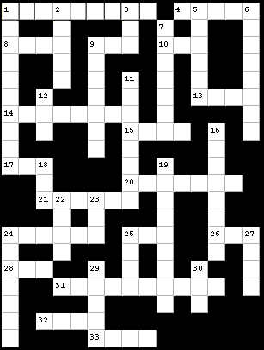
Clues
Across
- The Federal ____ Management Agency (9 letters)
- A natural disaster involving very high water (5 letters)
- An important evacuation route (4 letters)
- Where you take a bath (3 letters)
- A ____ of sunshine (3 letters)
- ____ and pepper (4 letters)
- It can keep the rain off you (8 letters)
- What you do with gum (4 letters)
- A hurricane swirls around an: ____ (3 letters)
- A funnel cloud (7 letters)
- Urban search and ____ (6 letters)
- Hurricane ____ runs from June to November (6 letters)
- All families need a Disaster Supply ____ with food, water and other items (3 letters)
- FEMA works with the American ____ Cross to help people in a disaster (3 letters)
- A long, flat fish (3 letters)
- This word means to reduce risk to your home from a disaster (10 letters)
- The federal agency that helps people during a disaster (abbreviation) (3 letters)
- All families need a Disaster ____ so you'll know what to do (4 letters)
Down
- A disaster caused by the ground shaking (10 letters)
- An important part of your disaster kit: a battery-powered ____ (5 letters)
- Corn on the ____ (3 letters)
- When it's cold, dress in ____ (6 letters)
- All homes need a smoke ____ (8 letters)
- It is important to ____ for disasters (7 letters)
- Another name for an earthquake (7 letters)
- If a disaster comes, you may be asked to ____ (leave your home) (8 letters)
- The shortened first name of President Lincoln (3 letters)
- A fire that sweeps through prairies, forests or other wide open areas is called a: ____ (8 letters)
- Listen for a tornado with your ____ (3 letters)
- When it's cold outside, you have to be careful about ____ (9 letters)
- Being a Disaster Action Kid isn't ____ (4 letters)
- Disasters happen, but people ____ prepare (3 letters)
- When you evacuate, you may stay in a ____ (7 letters)
- The husband of a queen (4 letters)
- In an earthquake, ____ and cover (4 letters)
- You should ____ your water heater to the wall (5 letters)
- If you evacuate, take your pet with ____ (3 letters)

Answer Key

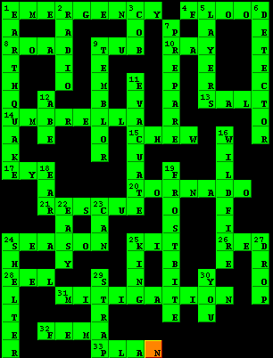
 | RUBRIC FOR MYSTERY MAPS | 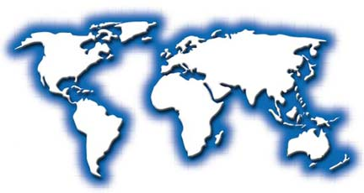

1/F 2/C 3/B 4/A

The 5 Map 1or 2 3 4 all 5

Essentials

name and heading

key

compass rose

latitude/longitude

title

Physical Geo 1 2-3 noted 4 5+

(mtns, rivers, seas, etc.)

Political Geo 1 2-3 noted 4 5+

(countries, cities,

states, etc.)

Color 1 2-3 colors 4 colors 5+

Errors many some errors few errors none

Every Mystery Map will be worth a value of 20 points. (5 categories @ 4 points each = 20). Yet, students may be able to earn extra points on any mystery map in which it is apparent that you went “above and beyond” in creating.

