Activities:

Bild A
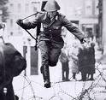
Teacher shows the picture A to the class; chooses any or all of the following suggestions for activities:

- Vocabulary development, practice w/the vocabulary
- Writing activity
- Students exchange writings, volunteers will read
- Teacher will ask “W” questions
- T. provides background information on the influx of “guest workers” into Berlin in the 1960s
- Listen to song
- Talk about Kreuzberg – Instandbesetzung (Bild B)
- Show picture Muslim family (Bild C) and ask questions, writing assignment
- Make connection between Islam – Kreuzberg by showing and talking about pictures and briefly discuss Islam and its foundations and beliefs.
- Writing assignment

Suggested vocabulary for 1:
Wortschatz:
der Soldat
der Zaun
der Stacheldraht
die Leute
das Gewehr
der Helm
die Stiefel
der Vordergrund
der Hintergrund

Practice: Teacher ask questions, s. a. Was sehen wir im V ordergrund? Etc.

Writing activty 2:
Hypthese aufstellen und aufschreiben:
Scheibt in mindestens 5 Sätzen was eurer Meinung nach in diesem Bild passiert!

3: Schüler tauschen es mit einem Partner, evt. laut vorlesen was geschrieben wurde. (Teacher collects assignment for correction suggestions and later assessment.)

4. Geziehlte Fragen stellen
Teacher ask the following questions:
Was passiert hier?
Wer ist der Mann?
Welche Nationalität hat er?
Wo ist das?
Wann ist das?
Warum springt er?

5. Veknüpfung mit türkischen Gastarbeitern:
1961 hat die deutsche Regierung einen Vertrag mit der Türkei abgeschlossen, türkische Gastarbeiter nach Deutschland zu bringen. Sie sollten helfen die deutsche Wirtschaft wieder aufzubauen. Die Arbeiter waren fast ausschliesslich „blue collar workers“.

6. Nächste Strophe von „Mein Berlin“ hören

7. Bild B – Kreuzberg, an occupied house
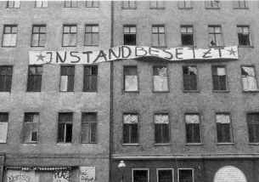

Was ist “instandbesetzt”?
(Background: In the 70s the Berlin government started to tear down many of the old building in Kreuzberg. Students, who needed cheap housing and the population who lived in this part of Berlin opposed the actions by moving into the building, thus preventing the demolition of the houses. It caused a lot of unrest, houses were burning, but it also helped to preserve most of the buildings, which were built around the turn of the century. Kreuzberg is now a cultural center with many renovated houses and restored charm.)

besetzt
instand / im Stande sein = beeing able to, funcional

8. Bild C – A Muslim family on the streets of Kreuzberg
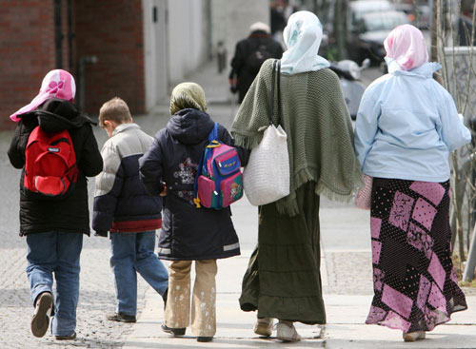

Questions:

Wer sind diese Leute? Wo sind sie? Warum sind sie da?

9. Islame in Kreuzberg
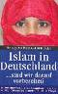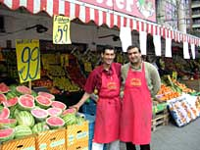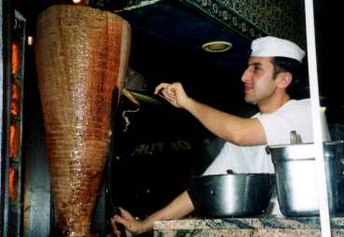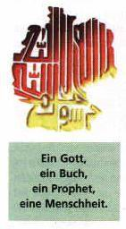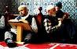

Show and discuss the different photos (Source: www)

Background:
Ethnic groups: | German 91.5%, Turkish 2.4%, other 6.1% (made up largely of Greek, Italian, Polish, Russian, Serbo-Croatian, Spanish)
There are 1.8 million Turks in Germany, 139,000 of them in Berlin alone, making them the largest group of foreign workers.

Religions: | Protestant 34%, Roman Catholic 34%, Muslim 3.7%, unaffiliated or other 28.3%

Information about Islam:

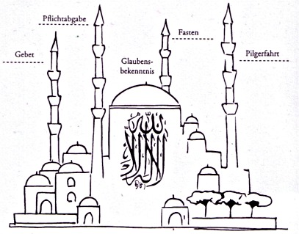

The 'Five Pillars' of Islam are the foundation of Muslim life:
Faith or belief in the Oneness of God and the finality of the prophethood of Muhammad;
Establishment of the daily prayers;
Concern for and almsgiving to the needy;
Self-purification through fasting; and
The pilgrimage to Makkah for those who are able.

10. Schreibe einen Leserbrief an die Zeitung!
(In Berlin are may emigrants from different countries. Take a position, discuss why it is beneficial to the city, and how you, a fellow Berliner feel about it and what citizens can do to live together and be more tolerant of each other). Keep it short! About 50 words.

