SAMPLE LESSON PLAN FORMAT #1

Date:
Unit: Who are the French
Grade Level: 7th
Lesson

Goals/Aims/Objectives | Standards

Body of Lesson:
Opening
Activities
Closing

How will the learning be assessed?
State specifically the evidence found in your assessment of student work that documents successful progress toward your goals and the standards.

Resources/Materials

SAMPLE LESSON PLAN FORMAT #2

Date: Subject: Grade:
Goals/Objectives/Standards:

Time | Opening/Framing the Lesson/Introduction/Early Assessment | Monitor/Feedback
 | The Lesson Structure: Activities
 | Closing/Assessment
 | Homework
Self Evaluation of the Lesson

Resources/Materials

SAMPLE LESSON PLAN FORMAT #3
Name: Karen Bryan Unit: chapitre 7 review
Text: Holt – Allez, viens, level one Grade Level: 8 (beginning of year)
Lesson: Religious diversity in American and French cultures
Goals: Students will …
Reduce stereotyping
Gain respect for diversity in U.S. and French cultures
Compare and contrast U.S. and French culture
Realize that populations of both countries are diverse, esp. in religious affiliation

Concepts

French population is religiously and ethnically diverse, just as the American population is diverse.

World Language Standards:
Standard 1
COMMUNICATION: Write and speak in a language other than English
Learners engage in written and spoken conversations on a variety of topics. (Interpersonal)
    - Accurately state information about self, family, and friends.
Standard 4
CULTURES: Develop awareness of other cultures
Learners examine, experience, and reflect on the relationships among the practices, products, and perspectives of the cultures studied.
    - Examine products, perspectives, and symbols of the target cultures through guided participation.
Standard 5
CONNECTIONS: Make connections to other content areas
Learners use the target language to expand their knowledge of and make connections among multiple content areas.
    - Investigate and report on objects and concepts from other content areas.
Standard 7
COMPARISONS: Investigate the nature of language and culture
Learners understand the nature of language and culture through comparisons of the languages and cultures studied and their own.
    - Compare the social patterns of other cultures and the learner’s own culture.

Materials:

Photos of American and French children and adults; clip art of religious symbols and places of worship.
Vocabulary: Adjectives of nationality (americain/francais); adjectives of religion (crétien, juif, musulman); Nouns: places of worship (mosquée, temple, synagogue, église)
Grammar: être - Il/elle est; ils/elles sont; c’est

Motivational Hooks:

Questions: What do Americans look like? What do French people look like? Then teacher will begin slide show (see “Framing the Lesson: Opening) of French and American photos to show the diversity of both cultures.

Framing the Lesson: Opening

Teacher begins with a slide show of various photos of French and American children, adults, and entire families at work, at play, at school, and at worship, without any accompanying commentary.

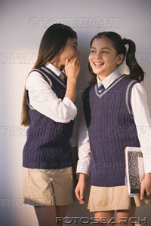

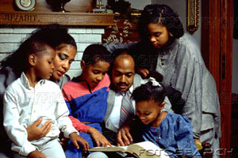

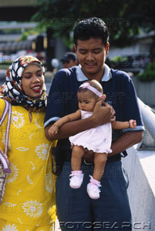

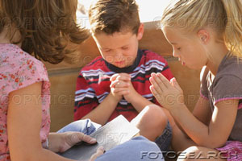

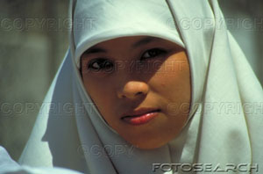

Activities: (in French class) Will take place over two class periods.

- Teacher asks, “What do Americans look like? After responses, asks, “What do French people look like?
- Teacher begins slide show (repeat of images in “Framing the Lesson” section) of American children and adult photos and asks, interchangeably: “Il/elle est américain(e)? Il/elle est français(e)?”
- After showing all the photos, teacher will go through slide show again and identify the photos with the statements: Il est américain, elle est française.
- Show pictures of places of worship. Show them a second time, this time with accompanying statements: “C’est une mosquée, c’est une église, c’est une synagogue.” Also introduce the adjectives: chrétien, chrétienne, juif, juive, musulman, musulmane.

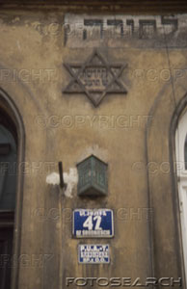

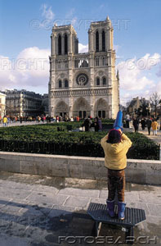

Also identify the following symbols of Judaism, Islam, and Christianity:

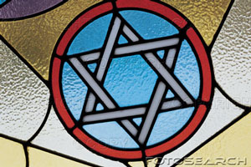

- Next, draw several stick figures, male and female singly and in groups on the chalkboard or overhead transparency. Draw a religious symbol next to each figure or group of figures. Ask questions “Il est muselman? Il est juif? Elles sont crétiennes? Les français sont muselmans? Les américains sont juifs? Il y a des français crétiens? Lead to discussion in English: What do French people look like? What do American people look like? Which religions do they follow?
- After discussion, summarize the main concepts: France and the U.S. have ethnically and religiously diverse populations.
- Show graph (following) with percentage of Muslim affiliation in France, the U.S., and other European countries. Students will interpret the graph in English by making statements, such as “Approximately 8% of France’s population is Muslim.”

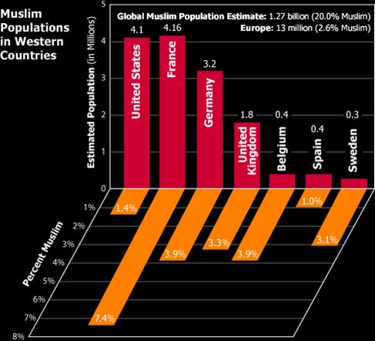

Closing:

Teacher will model a Venn diagram (following) with three sections headed “French” and “American” with an intersecting “Both” section. Students will participate in creating a list of differences (between the two cultures) in the French and American sections, and they will list the characteristics the two groups share in the intersecting “Both” section. Students will use information that they have learned throughout their French course about family life, school life, and other aspects of French culture. Students will then write a paragraph in which they discuss the similarities (many) and differences (few) between Americans and French, with a concluding sentence stating the main concept of the diversity of both cultures.

Assignment: Write a 5-paragraph essay comparing and contrasting French and American cultures using the information listed in the Venn diagram along with other information you have learned in your French course. Be sure to include:
- Aspects of American culture not typical in France,
- Aspects of French culture not typical in the U.S.,
- Cultural aspects shared by both cultures,
- An introduction, a well-developed body, and a conclusion to your essay.

VENN DIAGRAM - FRENCH AND AMERICAN CULTURE

FRENCH BOTH AMERICAN
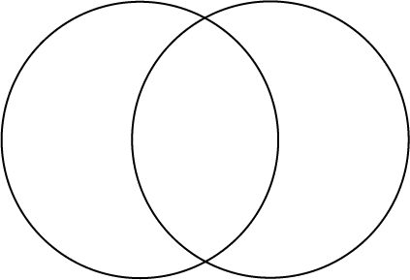

Adaptations of the Above:

With the 7th grade class, also use the lesson as an opportunity to review the basic concepts of adjective formation in French with the new adjectives “français, américain, chrétien, musulman, juif” after Chapter 3 of Holt Allez, viens, level one.

Cross Curricular Activities: (I also have my 8th grade French students for Language Arts class immediately following their French class, and I attempt to make connections between the two subjects whenever possible.)
Language Arts Standards:
Standard 8.3.5 Identify and analyze recurring themes that appear frequently across traditional and contemporary works.
Standard 8.5.2 Write responses to literature that connect response to the writer’s techniques and to specific textual references.

Language Arts: analyzing theme in essay “Words to Sit in like Chairs,” by Palestinian-American writer Naomi Shihab Nye; writing response to essay, citing specific textual references

Three days for reading the selection and writing the essay and one additional day for revisions to the essay.

- Students will read the essay “Words to Sit in Like Chairs,” by Palestinian-American writer Naomi Shihab Nye in their Prentice Hall Literature books, p. 1038, and the entire class (with the teacher) will analyze the theme of tolerance which is present in the essay.
- Students will respond to the reading by analyzing the writer’s technique (writing in first person) and its effect on the theme of the essay.

Math: reading and interpreting graphs on Muslims in France, U.S. and other European countries.

Assessment

Use the Indiana Department of Education ISTEP+ Applied Skills Language Arts rubric to assess the content, word choice, and language conventions of the compare/contrast essay.
http://doe.state.in.us/istep/2005/Data/47030Web_07eTSG_f05IN.pdf

